**Australia’s most awarded Change Project approach**

**combined with Australia’s highest profile horse handler (*as seen on ‘60 Minutes’, The Today Show,‘Random Acts of Kindness’ etc)….***

**P**lanning

**A**nd

**L**eading

**A**

**C**hange

**E**ndeavour

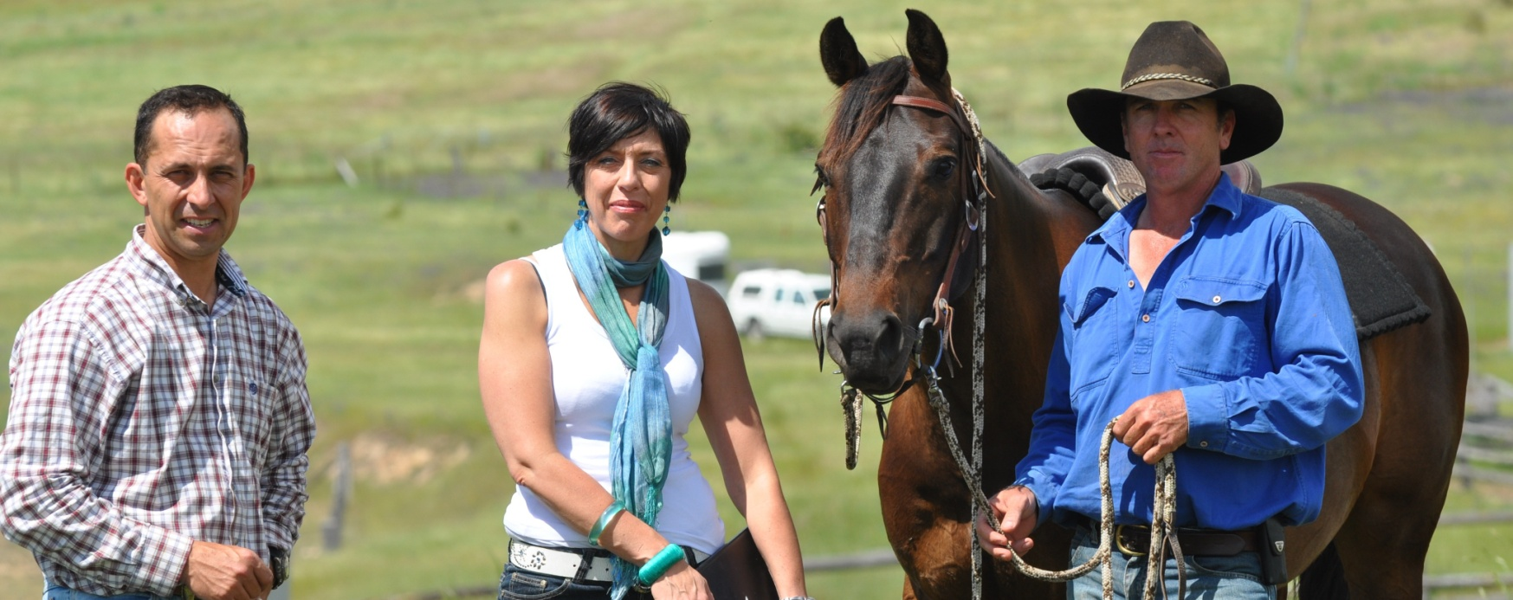

**“Planning And Leading a Change Endeavour”**

**5 day residential**

**PROGRAM DATES**

TBA

**WHO SHOULD ATTEND**

Business leaders, senior executives, managers, supervisors and other professionals in positions of leadership or recognised with leadership potential

**Introduction**

The PALACE Program is an innovative way to plan a change project and develop leadership skills and qualities. The 5-day residential program combines theory and strategies of leadership and change management with the priceless lessons that only horses can demonstrate.

The PALACE program is centered around the development of a change project utilising the most awarded change management project methodology in Australia. You will apply this methodology to plan the key elements of a change project. Throughout the program you and your team will have the opportunity to observe and engage with horses and gain a better understanding of your own approach to leadership and change management. (NB. participants do not ride horses)

**Why use horses?**

Horses demonstrate similar behaviors to those often displayed by humans. Horses are uncomplicated creatures and honest communicators, providing you with immediate feedback about your effectiveness in leading, communicating and working with others. Through the process of observing horses and developing a meaningful partnership with them, you will gain an insight into your own emotions and behaviors and develop strategies for transferring key learnings to the workplace.

[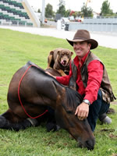](http://www.horsehandler.com.au/photographs/photo.php?ID=61)

**What will you leave with?**

* A detailed Change Management Project Plan
* A personalised Team Profile
* The experience of a lifetime

**What will you learn?**

You will leave the program with fresh perspectives and tangible action plans to effectively plan and lead change endeavours in the workplace. Specifically, you will be able to:

* Apply project management planning methodology to plan a change project (endeavour)
* Gain an increased understanding of your personal leadership style and the impact it has on others
* Learn valuable lessons for the workplace from interacting with horses
* Develop strategies for enhancing leadership performance in the workplace

**FOR MORE INFORMATION**

Phone 0430 432445

**Greg Powell**

Greg Powell has made a career out of building partnerships with horses.

Having worked with horses since he was a boy, Greg has gained a wealth of experience and knowledge in the art of building lasting relationships with horses. Greg has come to believe and agrees that a special relationship with a horse can only be achieved through mutual trust and understanding and not fear and intimidation.

Greg has appeared in many feature magazine and newspaper articles and on numerous radio and television shows. He has also appeared at a huge number of field days, horse events, clinics and other media related live events, demonstrating his horse handling skills with 'Snowy the Brumby Mare', 'Sammy the Arab' and 'Bruce the Kelpie'!

Greg Powell's work with wild horses in the Snowy Mountains high country has generated much interest in recent years and was profiled in the [documentary](http://www.horsehandler.com.au/documentaries.php) film - "[The Horse Handler](http://www.horsehandler.com.au/shop/product_details.php?ProductID=2)".

The documentary “[Wild Horses, Wild Kids](http://www.horsehandler.com.au/shop/product_details.php?ProductID=3)” features Greg's work with Father Chris Riley, the founder of Youth Off The Streets, and some young adults chosen by Father Riley to participate in the brumby project. Greg has conducted numerous workshops for all levels of management including the Young Presidents from the US. Several participants from the Young Presidents commented that the days they spent with Greg and his horses demonstrated leadership lessons that they found invaluable. Greg has recently won Equitana's Way of the Horse Competition.

Catherine has over 20 years experience in the field of learning and development; management and leadership; and organisational change. She is an experienced manager and leader having held middle and senior management positions within government and private industry organisations as well as owning and operating several small businesses.

Her specialist skills in coaching and training enable Catherine to inspire individuals to realise their full potential and maximise individual performance and team effectiveness. She is able to understand the challenges that many managers and organisations face and help clients generate strategies to address such challenges. Catherine is dynamic in her approach and has designed and delivered coaching and training programs for a range of clients from new managers through to established executives, business leaders and CEOs. Her expertise is equipping individuals for their next level of management and leadership especially developing first time managers to achieve peak performance.

To support her extensive experience in the field of management, leadership, and organisational change, Catherine is a certified Trainer, Master Coach and Practitioner of Neuro-Linguistic Programming (NLP); certified Master Practitioner of Time Line Therapy®; has an Advanced Diploma of Management, Diploma of Government; qualifications in training and assessment and change management accreditations.

**Catherine Bowyer**

Catherine is an executive coach and trainer specialising in creating high performance managers, leaders and teams. She provides an objective and insightful view into the current performance of her clients and helps them to maximise their performance and achieve results instantly!

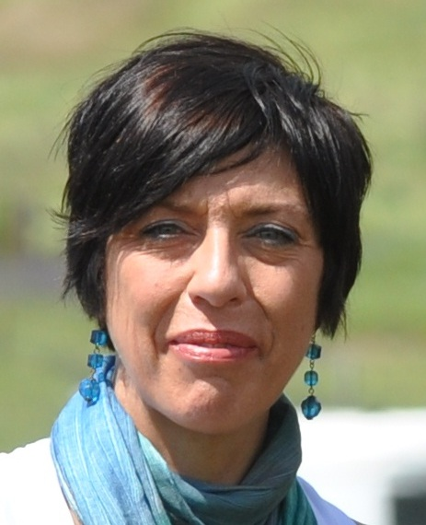

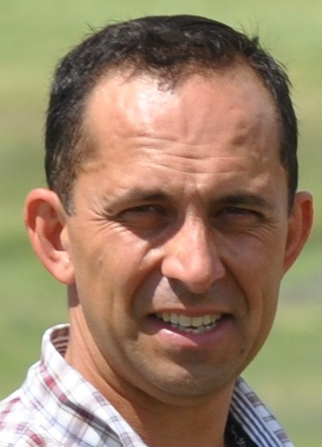tt

During Scott’s workshops, participants usually form teams and plan a work based project. Key planning templates are explained and groups practice their compilation with their nominated project. The workshop is therefore a great opportunity for project teams to ‘start-up’ a project whilst learning the techniques and gaining expert facilitation for their outline project plan.

Scott’s approach has resulted in the direct award of 3 National Project of the Year titles and 8 State level Project of the Year titles including **2007 and 2010 National Change Management Project of the Year Awards** (all awarded by the Australian Institute of Project Management). The approach has also indirectly lead to numerous other National and State level awards.

**Scott Sutherland**

Scott Sutherland has been training participants in project management at the formal qualification level for 13 years. Scott’s standard 3 day program is extremely intensive and concentrates on helping participants gain a sound understanding of project management processes. It also provides them with practical advice on using this knowledge to effectively manage their projects.

**PROGRAM FACILITATORS**

**PROGRAM OVERVIEW**

**DAY 1**

* Introduction to Project Management
* The Essence of Leadership
* Introduction to Horse Exercises
* Stakeholder Analysis
* ‘Lock on’ - Activity with Horses

**DAY 2**

* Leadership Effectiveness
* Leadership Styles
* Project Scope
* Positive Partnerships - Activity with Horses
* Work Breakdown Structure
* Organisational Leadership

**DAY 3**

* Work Breakdown Structure (con’t)
* Positive Partnerships -Activity with Horses (con’t)
* Organisational Leadership (con’t)
* Microsoft Project
* Analysing Critical Path

**DAY 4**

* Risk Analysis
* Communications Plan
* Issues Register
* Project Meetings
* Managing Resources
* Creating High Performing Teams
* Setting Goals & Direction - Activity with Horses

**DAY 5**

* Horse Sorting Activity
* Monitoring and Controlling Projects
* Team Obstacle Course - Activity with Horses
* Evaluating Leadership Effectiveness
* Presentation of Project Plans
* Program Review and Action Planning
* Certificate Presentation and Close